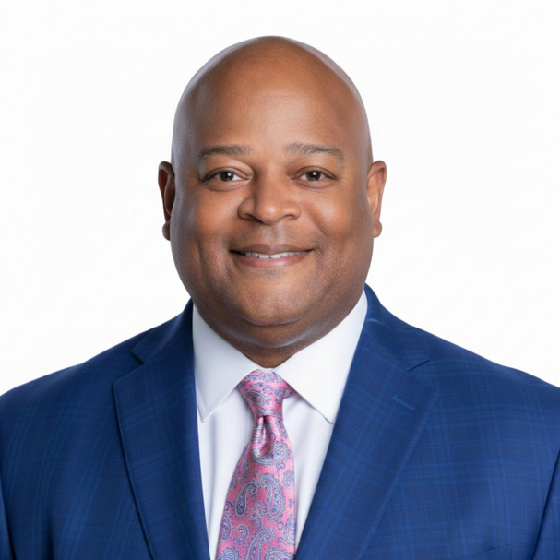
Carlos Phillips, CCE, serves as President and Chief Executive Officer of the Greenville Chamber of Commerce, a 137-year-old business and economic development organization dedicated to building a globally competitive region where businesses and people thrive. Known for his strategic vision and commitment to fostering inclusive economic growth, Phillips has built a career defined by measurable impact and community-focused leadership.

Under his leadership, the Greenville Chamber has reached several major milestones, including earning 5-Star Accreditation from the U.S. Chamber of Commerce, strengthening its financial position, and delivering multiple strategic plans that support long-term growth and innovation. The Chamber earned 2021 Outstanding Chamber of the Year recognition from the Carolinas Association of Chamber of Commerce Executives, and Furman University honored the Chamber with its Community Partner Award in 2026, reflecting the organization’s deepening regional impact. Phillips also led the statewide expansion of the Minority Business Accelerator, guided the development of a Diversity and Economic Inclusion Strategic Plan, and championed legislation advancing second-chance employment opportunities for formerly incarcerated individuals.

Phillips’s leadership is recognized across the Upstate and nationally. He has been named among Greenville Business Magazine’s “Top 50 Most Influential” and inducted into its Hall of Fame. He has chaired the Association of Chamber of Commerce Executives Board of Directors and currently serves on the U.S. Chamber Board of Directors. His community involvement is extensive, including leadership roles with the UNCF Upstate Mayor’s Masked Ball Leadership Council and board service with the Community Foundation of Greenville, Urban League of the Upstate, VisitGreenvilleSC, and the United Way of Greenville County, where he was named Advocate of the Year in 2018.

Phillips holds a Bachelor of Arts in Communication from the University of Kentucky and a Master of Arts in Organizational Communication from Western Kentucky University. In 2023, he earned the Certified Chamber Executive (CCE) designation, the highest individual recognition in the chamber profession.

