Finding What You Need From Congress.gov

Step 1- go to https://www.congress.gov
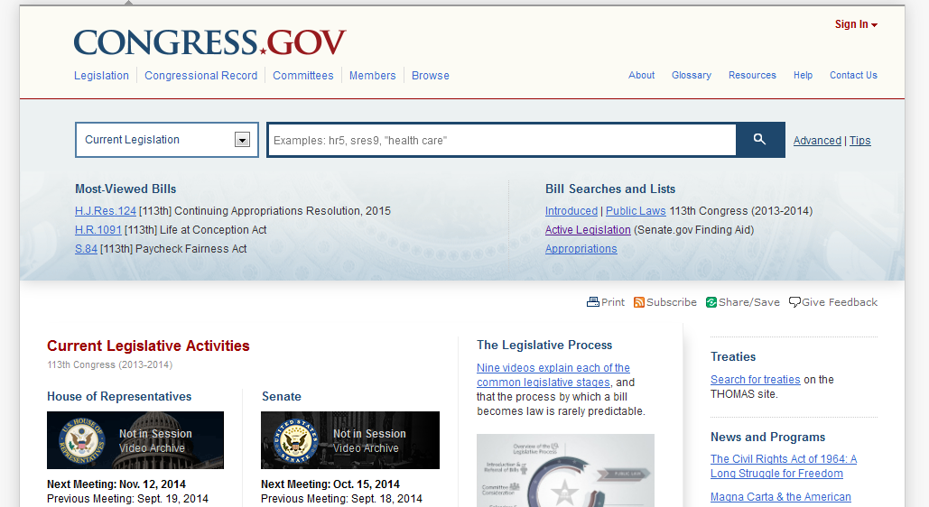

The first thing that you and your students need to do is to create an account. This will enable you to save searches and do many helpful things that will help you build your research. If you click the “Sign In” link in the upper right corner of the page, you can register and then be able to save your searches.

Step 2 – Spend some time exploring current legislation. (note: There are also several helpful videos on Legislative Process that you can show your students before starting the actual research.)
There is a convenient search window that is easily used.
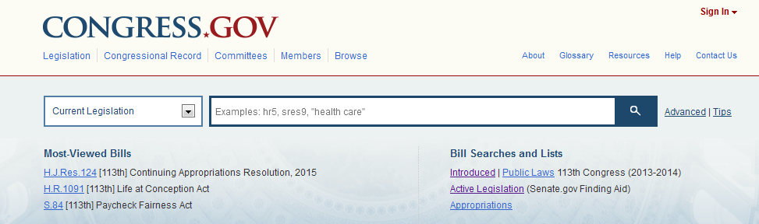
To search for legislation, if you are not sure what to look for, you can click on one of the links under “Bill Searches and Lists,” which will take you to another page where can narrow down your search by various criteria. For example, you can look for bills by issue such as “Healthcare” or “Environmental Protection.” You then narrow down your search criteria to focus on a particular piece of legislation that interests you.
You can also choose to narrow your search to bills that have already been signed into law. This anables you to shorten the time it will take to complete this lesson.

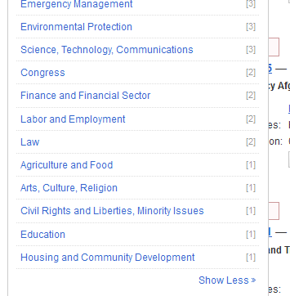
You will see how many bills related to your chosen topic. For example, in the picture to the left, you will see that there were 3 bills that passed relating to Environmental Protection, and one that related to Education.
If you click on one of the topics, you will be presented with those bills (see image below).

In the image below, note that you have a great deal of information relating to who introduced the bill, and how if moved through its journey to becoming a law. You can click on the link to the law and see its actual content then.

