FURMAN OLLI PARKING PERMIT DECALS

Parking decals must be displayed on the rear window exterior, passenger side, lower corner (see illustration).

Failure to display or improper display of a permit may result in a citation from university police.

OLLI member permit decals are white with orange text. The permit text color (orange) must match the lot color as specified at the entrance sign of each lot.

If your parking decal needs to be replaced for any reason (ex. loss or a new car purchase), replacement decals are available in the OLLI office.

Where do I park?

OLLI members with Furman parking decals may park in the following Orange Lots:

- Herring Center
  - In front of the Herring Center
  - In the lot adjacent to Timmons Arena

- 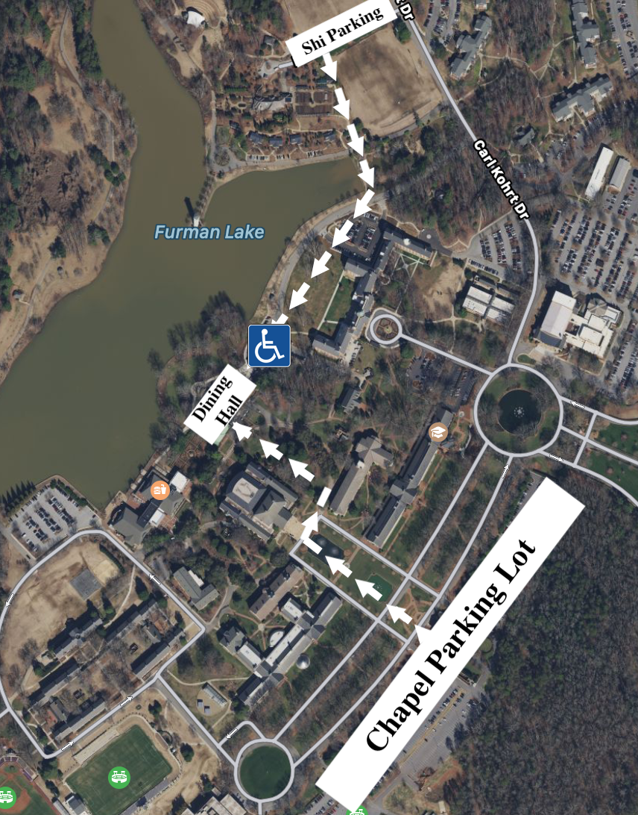Trone Student Center and Daniel Dining Hall
  - Park near Daniel Chapel in the orange-coded section or by the Shi Center. A limited number of handicap spaces are available in the Trone parking lot and the small parking lot beside the Dining Hall.
  - The Trone lot is 30-minute parking only for all visitors and students from 8 a.m.- 5 p.m. After 5 p.m. OLLI members are permitted to park for an unlimited time in restricted lots.

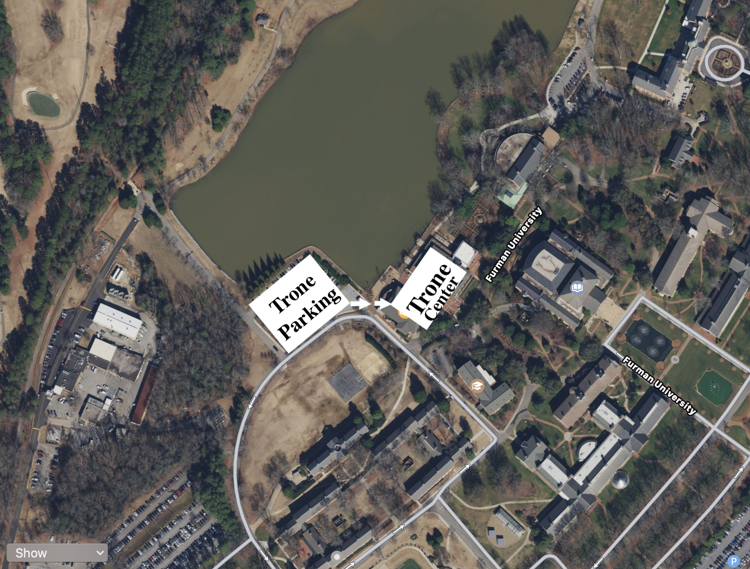

- Daniel Music Building
  - Park to the right or behind the building in spaces NOT marked RESERVED. (Park in the orange-coded section.)

- North Village Building J
  - Park in front of building J or the parking lot surrounding the building in spaces NOT marked RESERVED.

- Physical Activities Center (PAC)
  - Park in the back two rows of the lot closest to the PAC (in the orange-coded section).
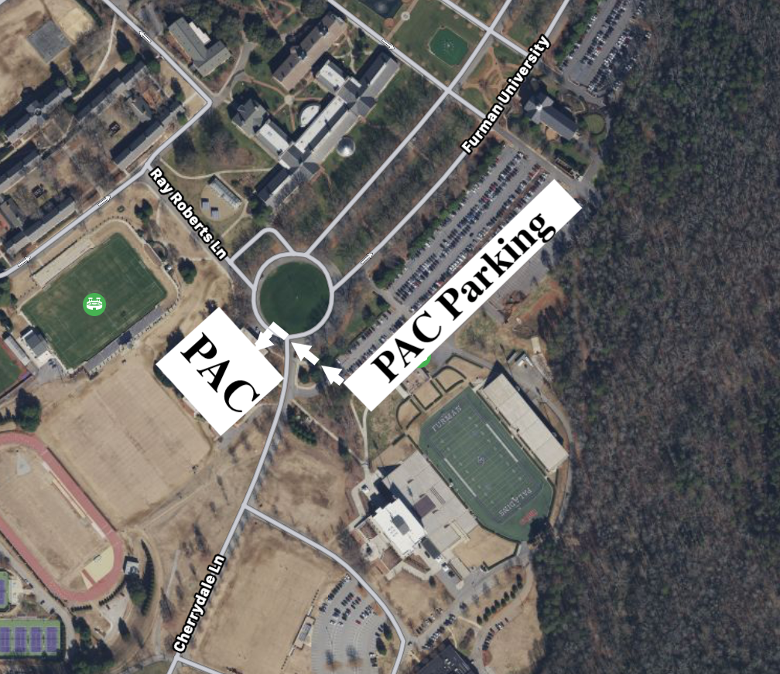

Frequently Asked Questions:

If I have a 2019-2020 octagon shaped Furman OLLI parking decal, do I need a new parking decal?
- Yes, the 2019-2020 decal has expired. Parking permits need to be replaced each school year. The 2021-2022 decal is circular shaped and included with OLLI membership. Parking decals are available in the OLLI office.

If I get a new car or lose my Furman OLLI parking permit decal, will I need another decal?
- Yes, replacement permit decals are available in the OLLI office.

If I have a handicap parking permit, do I need a Furman OLLI parking permit decal?
- Yes, Furman requires all OLLI members to register their cars and obtain a Furman OLLI parking permit decal.

If I have a PAC parking permit, do I need to a Furman OLLI parking permit decal?
- Yes, Furman requires all OLLI members to register their cars and obtain a Furman OLLI parking permit decal. OLLI members are considered commuter students. PAC members are not.

If I have a Heritage Society parking permit, do I need a Furman OLLI parking permit decal?
- No, Heritage Society parking permits cover parking while on the Furman campus.

If I have a Lifetime Community Membership parking permit, do I need a Furman OLLI parking permit decal?
- No, Lifetime Community Membership parking permits cover parking while on the Furman campus.

