Learning with Zoom: “Tips and Tricks”

Muting yourself if you call in to Zoom

Before joining a Zoom lecture, a pop-up window will appear asking if you would like to “Join with Computer Audio,” this will allow you to listen to the class. (Suggestion: select “Automatically join audio by computer when joining a meeting” at the bottom of the pop-up window for future Zoom classes.)

When joining a Zoom lecture, your microphone is automatically off. To mute or unmute yourself, click the microphone icon at the bottom left corner of your screen.

How do I rename myself in Zoom?
To rename yourself on Zoom, click the “Participants” icon at the bottom of the screen.

Then, the “Participants” window will open on the right side of your screen. Hover over your name with your mouse and click “More.”

After selecting “More,” select “Rename” for a pop-up window to appear in the center of your screen. Then, in the text box put your name as you would like it to be seen by others and select ‘OK’. Your name should update immediately.

How do both my spouse and I join the same Zoom class?
If you and your spouse (or you and your partner) are enrolled in the same Zoom class, we recommend that you join the class on only one device. Run Zoom on your laptop, desktop, tablet, or smartphone and sit together like friends for the class! You can rename yourself to include both people using the above instructions.This is recommended over using two screens because audio feedback can be quite bad if the screens can “hear” what’s going on with each other.

How do I share my face in Zoom?
When joining Zoom, your webcam will automatically be turned off. If you’d like to turn on your webcam, select the “Start Video” icon at the bottom left corner of your screen to start your video.

How do I chat on Zoom?

“Chatting” on the Computer
- Launch the Zoom app and enter the meeting.
- In your controls at the bottom window, click Chat.
- The chat window will open on the right side of your screen. You can type your message into the chat window and press the “Enter” button on your keyboard to send your message.

“Chatting” on your Smartphone or Tablet
- Launch the Zoom app and enter the meeting. You will see your profile picture on the screen.
- Tap on someone in the meeting, and the toolbar will appear at either the top, on an iPad or iPhone, and on the bottom of the screen for Android devices.
- Tap the “Participants” speech bubble in the toolbar to view a list of meeting participants.
- Tap the “Chats” button or the arrow next to a participant’s name, and a chat window will appear.
- Using the arrows, you can chat privately with one participant, or chat with everyone in the meeting.

It will look like this on an iPad or iPhone: It will look like this on an Android:
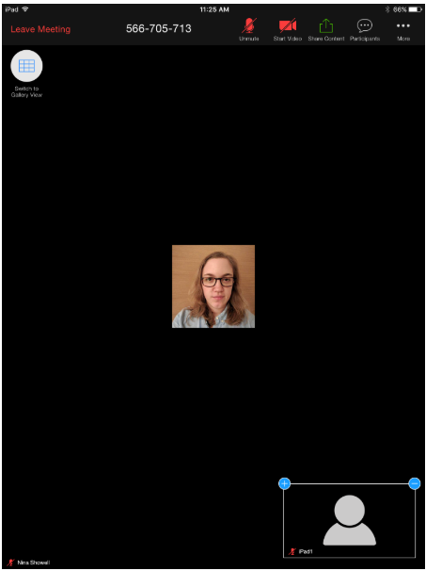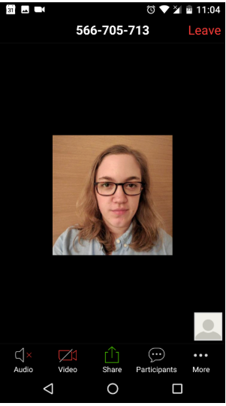

Can I change my “view” in Zoom?

Zoom video layouts include the following: Full Screen, Active Speaker, Gallery View.
- Full Screen Mode allows you to see the entire Zoom screen.
- Active Speaker is the default layout in Zoom. It will switch to the large video window between those that are speaking. Whoever speaks will be featured in the largest window.
- Gallery View allows you to see thumbnail displays of everyone in class, arranged in a grid. You will use the arrow feature to scroll through the rows of peers in class with you. Depending on your computer, you can display up to 49 attendees in a single screen. If there are more attendees, you will use the arrow key to scroll through each page of attendees.

Changing view on the Computer
To access Full Screen, click on the icon with the four arrows at the top right corner of your Zoom window.
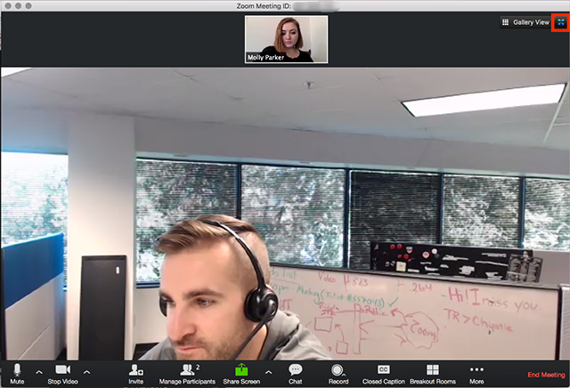
To exit Full Screen, press Exit Full Screen in the same location or use the Esc key on your keyboard. (Note: In older versions of MacOS, select the Meeting tab and Enter Fullscreen in the Top Menu bar).

To access Gallery View, click Settings and then click Video to display video settings.
- Enable the option to Display up to 49 participants per screen in Gallery View. Note: depending on the processing power of your computer, this option may be unavailable.
- Start or join a meeting.
- Click Gallery View in the top-right corner.
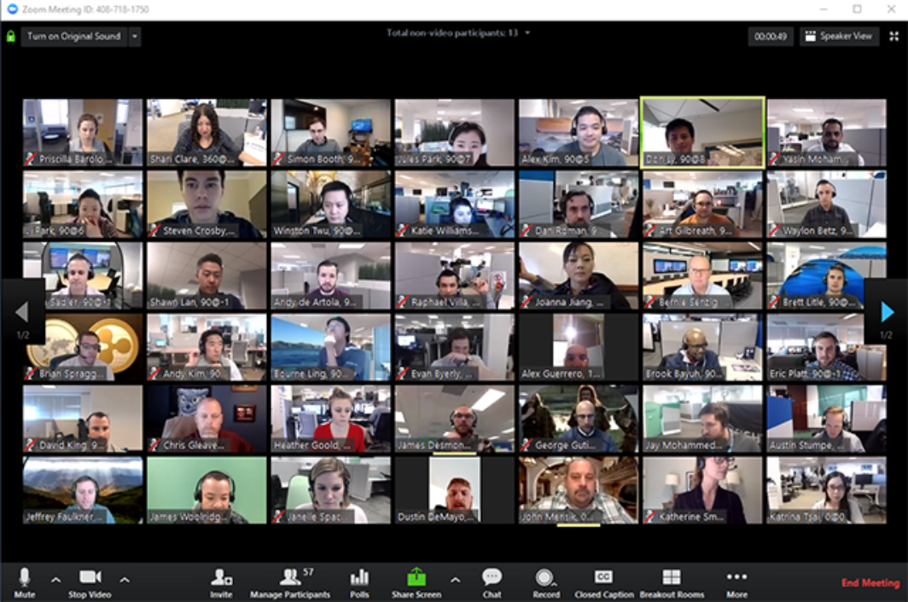

Can I connect my Zoom classroom to my television?

Yes, you can! This is a really advanced “Zoom move.”
- Using an HDMI cable (or if you have a Mac, an HDMI cable and dongle/adapter), plug your computer (laptop or desktop) into your television.
- Change the “source” on your television to the HDMI
- On your computer find the “Project” setting. On your computer, change “Project” to either “Duplicate,” “Extend,” or “Second Screen Only.”
- Now your Zoom class will be on your screen! You’ll still need to use the keyboard and mouse of your computer to interact with class.

