Log into Established OLLI Account/Register for Classes

If you have been an OLLI member or taken an OLLI class at any time, you have an established account.

1. | Go to the OLLI@Furman website: Furman.edu/olli
2. | Click on this link to go to the OLLI @ Furman registration page. | 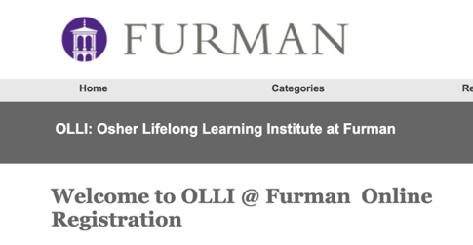
3. | You will see this registration page.  Fill in your username and password to Sign In to Existing Account.  Click the Sign In button below Password. | 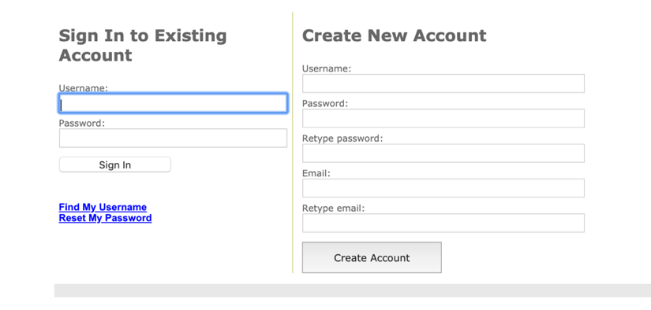
4. | You will be taken to the Shopping Cart page where you will see information on how to register for classes. Make sure you see Welcome, Your Name in the top left corner.  If you are ready to register for classes (and it is on or after May 12), you may click on Return to Course Catalog Page (in the gray box). | 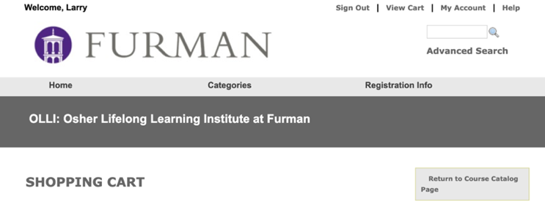
5. | That will take you a listing of course categories.
6. | Click on the course category ex. Arts. Culture, Literature and Music to see the individual courses (to the right in gray) that are available. | 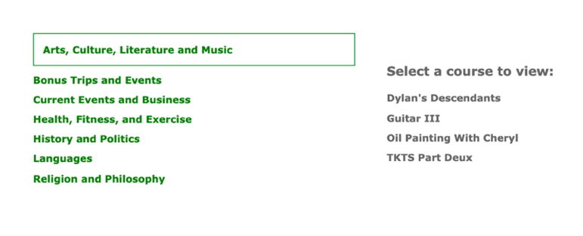
7. | Click on the course you would like to take (ex. Dylan’s Descendants) for a description of the course.  If you would like to register for the course, click on the Add to Cart button at the bottom left of the gray box. It will take you to your Shopping Cart.  If you would like to take more courses, click the Return to Course Catalog page in the gray box located at the top right of the page. | 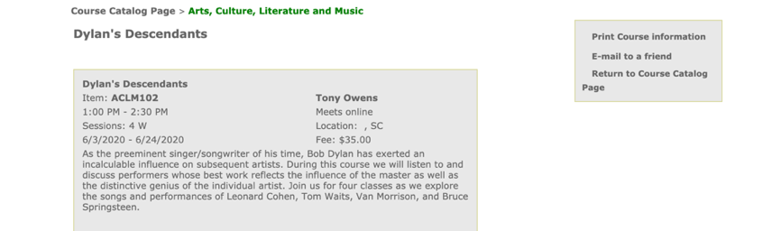
8. | Once you have selected all your courses, please preview your shopping cart carefully and proceed to check out by clicking on the checkout button. | 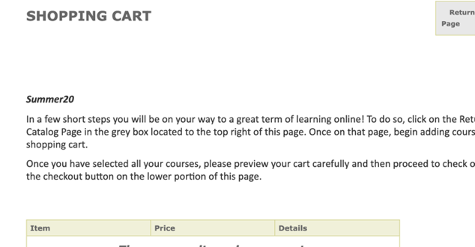
Continue to follow the directions to checkout. Once you have completed your transaction, you will receive an email receipt. If you do not receive an email receipt, check your cart to make sure you checked out all the way and did not leave courses sitting in your cart.

If someone else is registering for classes on your computer or you are registering them, make sure you click the Sign Out button located at the top right of your account. That will allow you to sign out of your account and sign in to theirs.

