How to Reset a Password
1. | Go to the OLLI@Furman website, Furman.edu/olli
2. | Click on this link to go to the OLLI @ Furman registration page. | 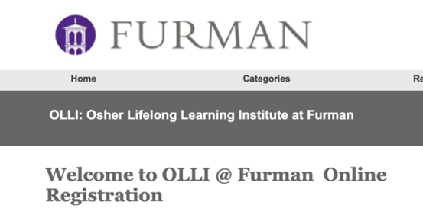
3. | Fill in your username and password to Sign In to Existing Account  Be sure to write down your username and password, so you can remember your login information.  We suggest using first name.last name as your username ex. Username: Larry.Brown | 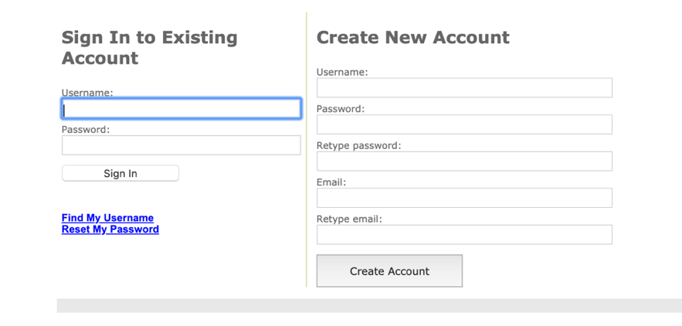
4. | After completing your username and password, click Sign In. If you receive this red message Invalid username or password, here is how you fix the problem. | 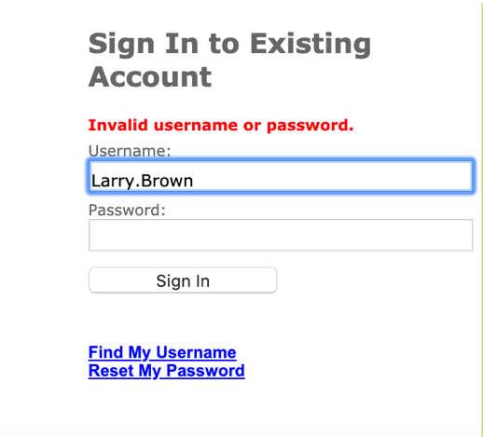
5. | Click on the blue words, Reset My Password. | 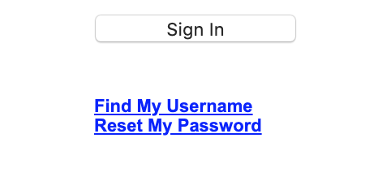
6. | You will be directed to this page. | 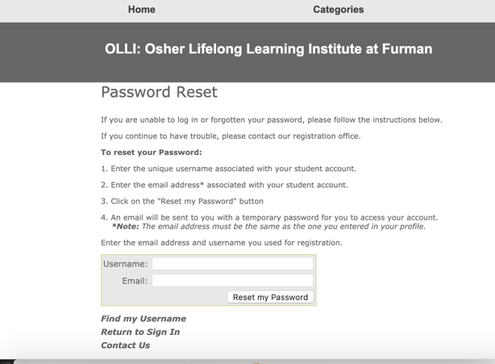
7. | Fill in your username and email and click Reset my Password. | 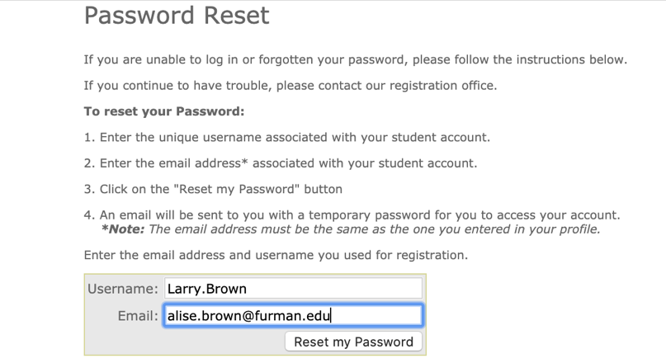
8. | Once you click Reset my Password, an email with a temporary password will be sent to your email account. | 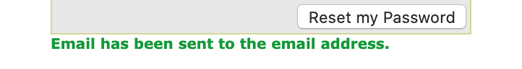
9. | Check your email inbox (and/or spam folder). The email will be titled: Your OLLI @ Furman password. | 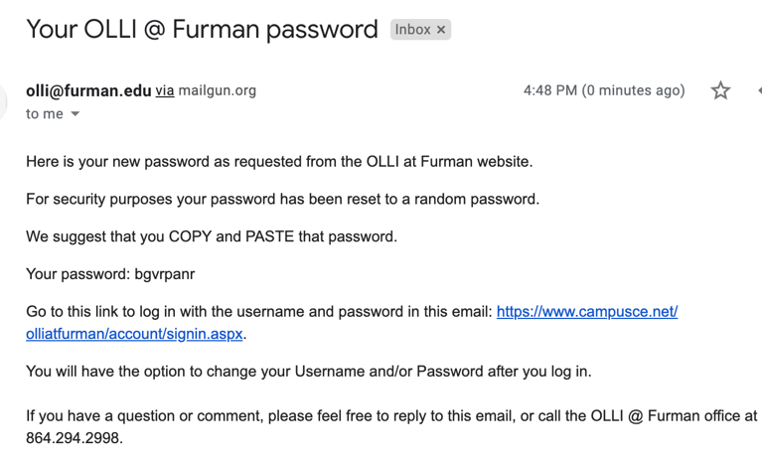
10. | Copy and paste the computer-generated password (in this case bgvrpanr) and use it to sign in to your OLLI account under your username. | 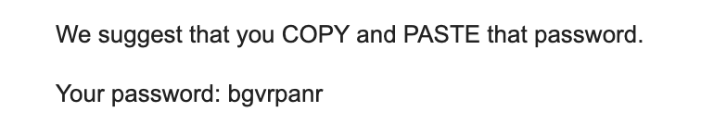
11. | Return to the OLLI registration page and Click Return to Sign In to go to the Sign In to Existing Account page. | 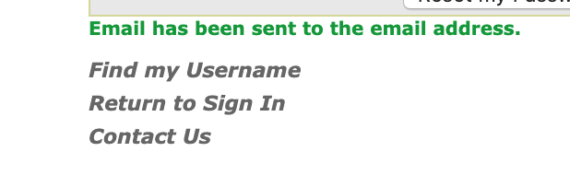
12. | Sign in to Existing Account with username and computer generated password. | 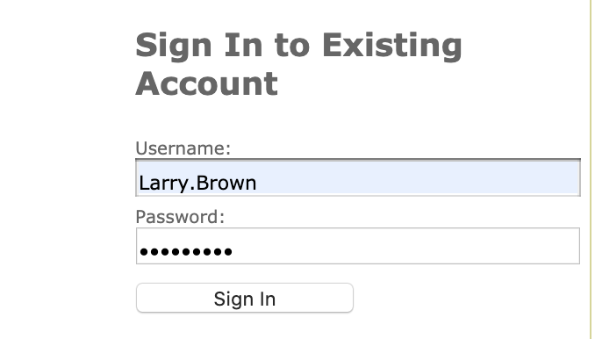
13. | You will be directed to this page where you will put the computer-generated password in the space beside Old Password and your new password in the two spaces where it says New Password. | 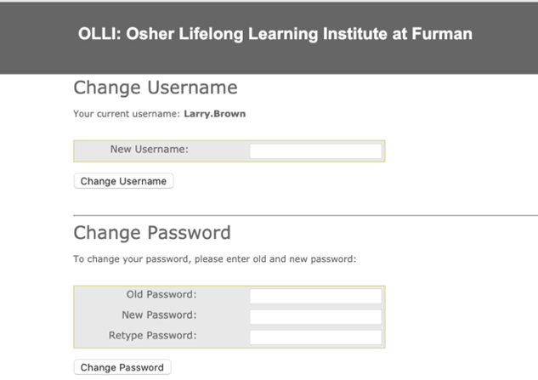
14. | Click Change Password. | 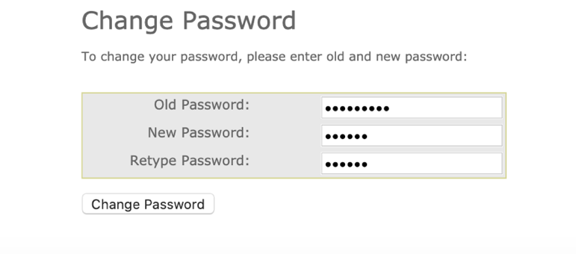
15. | You will see green words that say, Your password has been updated! | 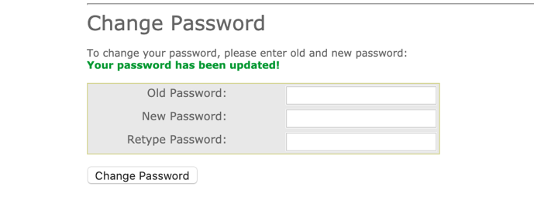
16. | You will know that you are signed in to your account, when you see, Welcome, First Name at the top left of the page. | 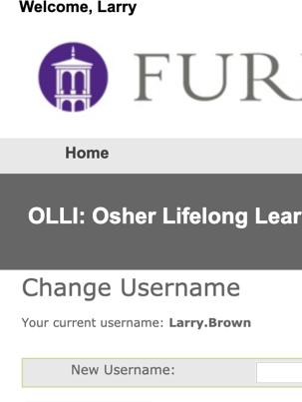
17. | If you are ready to register for classes (and it is on or after May 12), you may click on Return to Course Catalog Page (in the gray box). That will take you a listing of course categories. | 