Are you new to OLLI @ Furman? Welcome! Here is how you make an OLLI account that will allow you to register for fantastic classes.

1. | Go to the OLLI@Furman website, Furman.edu/ollli
2. | Click on this link to go to our OLLI @ Furman registration page. | 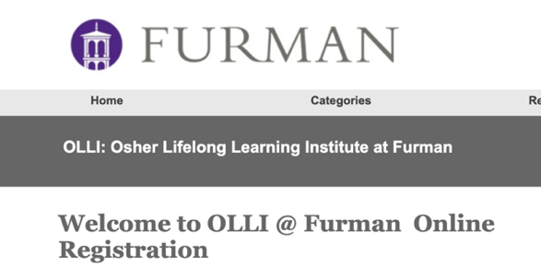
3. | Fill in the information below Create New Account  Be sure to write down your username and password, so you can remember your login information when your account is established.  We suggest using first name.last name as your username ex. Username: Larry.Brown  You will use the Sign In to Existing Account, once you have established an OLLI @ Furman account. | 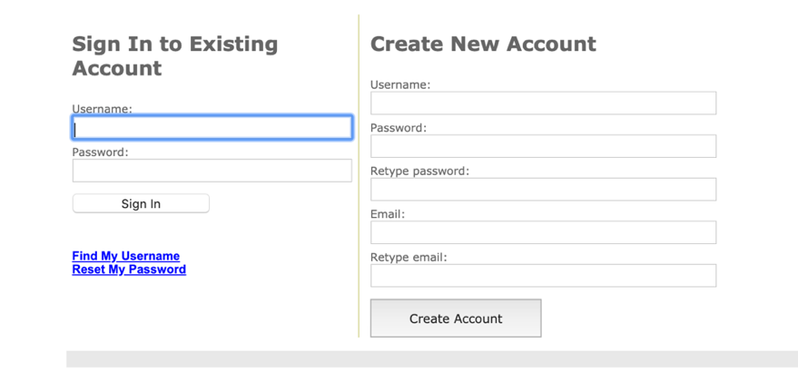
4. | After completing your username and password click Create Account. You will be taken to this page (My Information) where you will fill in additional information. | 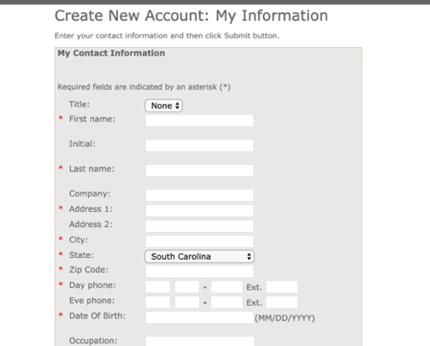
5. | After completing the information, click the submit button on the bottom right | 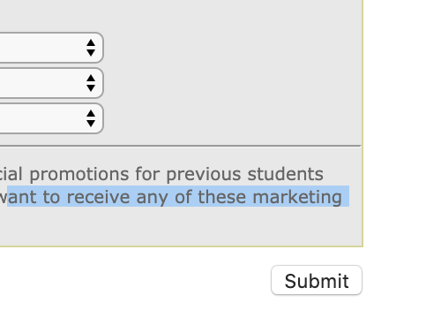
6. | Once the information is submitted, you will see your name in the top left corner and know you have completed your account! | 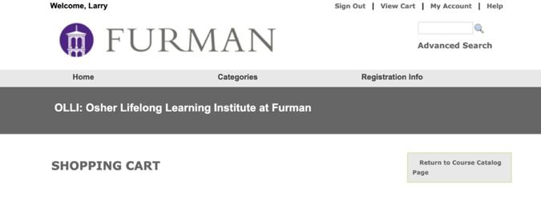
7. | If you are ready to register for classes (and if it is after May 12), you may click on Return to Course Catalog Page (in the gray box). That will take you a listing of course categories.
8. | Click on the Course category ex. Arts. Culture, Literature and Music to see the individual courses (to the right in gray) that are available. | 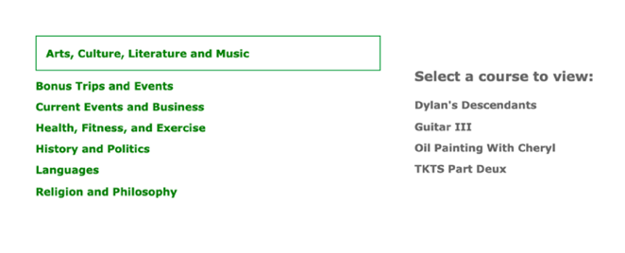
9. | Click on the course you would like to take (ex. Dylan’s Descendants) for a description of the course.  If you would like to register for the course, click on the Add to Cart button at the bottom left in the gray box. It will take you to your Shopping Cart. If you would like to take more courses, click Return to Course Catalog Page in the gray box located to the right. | 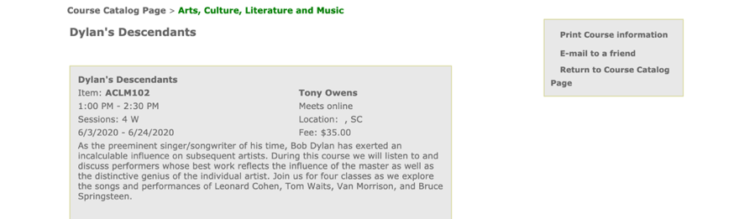
10. | Once you have selected all your courses, please preview your shopping cart carefully and proceed to checkout by clicking on the checkout button.  Follow the directions to checkout. Once you have completed your transaction, you will receive an email receipt (check your inbox and/or spam folder). If you do not receive an email receipt, check your cart to make sure you checked out all the way and did not leave courses sitting in your cart. | 