Go to: https://www.campusce.net/FurmanAdmin/signin.aspx
Your User Name and Password will be the same one you use to register for classes. If it does not work, please contact Pam or Susan for assistance at 294-2998.
First: Login to CampusCE. (It will direct you to the page in the second step)
Second: Under the bold tab My Settings, Click on My Profile:
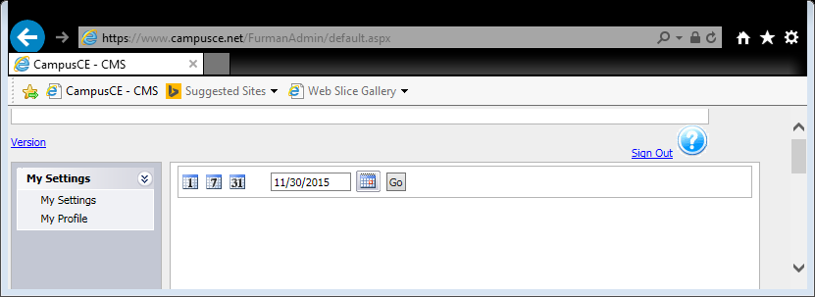
Third: On the blue bar, click on the Reports tab. 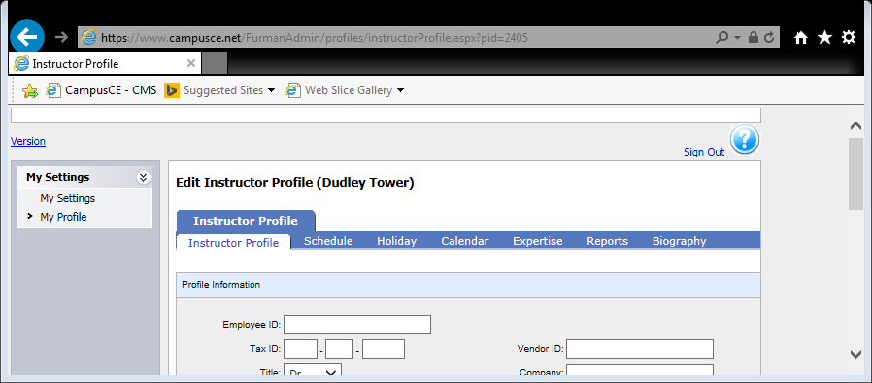

Fourth: You should now see all the classes for which you are registered as an instructor.
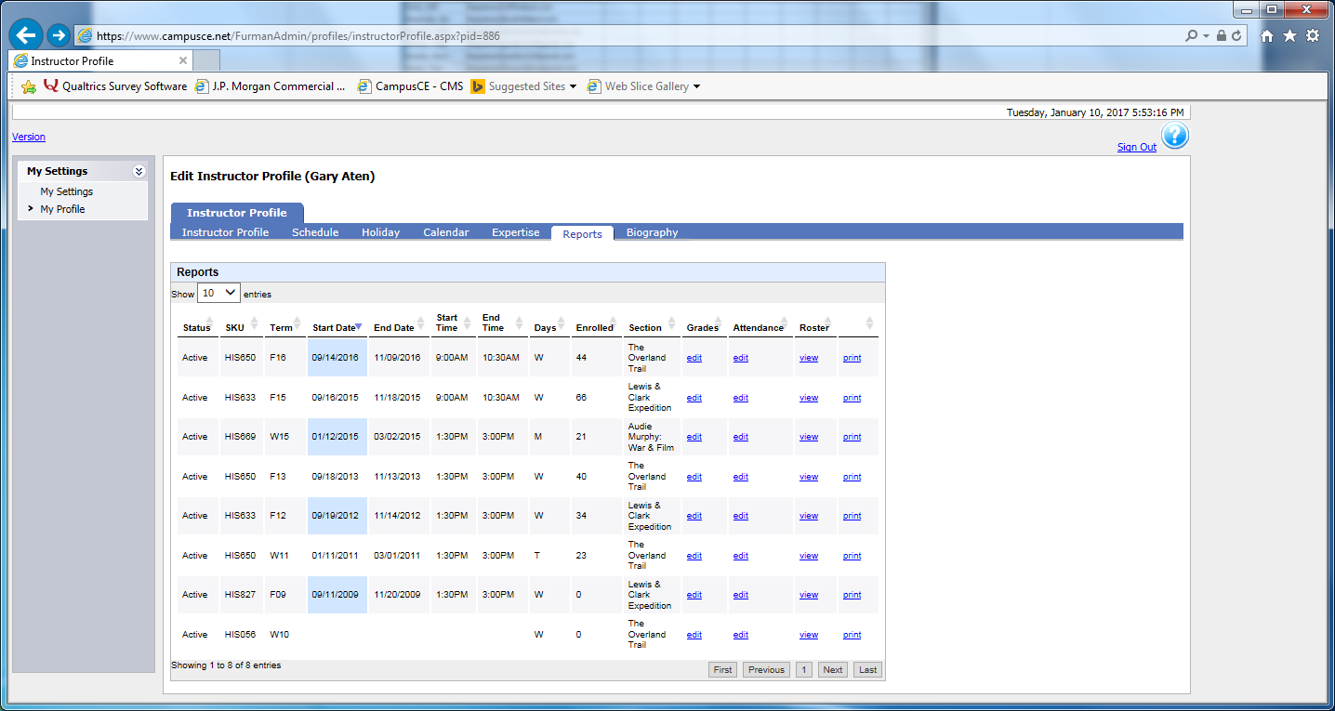
Fifth: Under the Roster heading on the black bar, click View to display the appropriate class roster. Do not use the PRINT tab because it will include those on the waitlist and those who have dropped the class. You can copy and paste the entire page into an Excel spreadsheet and then copy and paste the email address column to the BCC line to send an email.
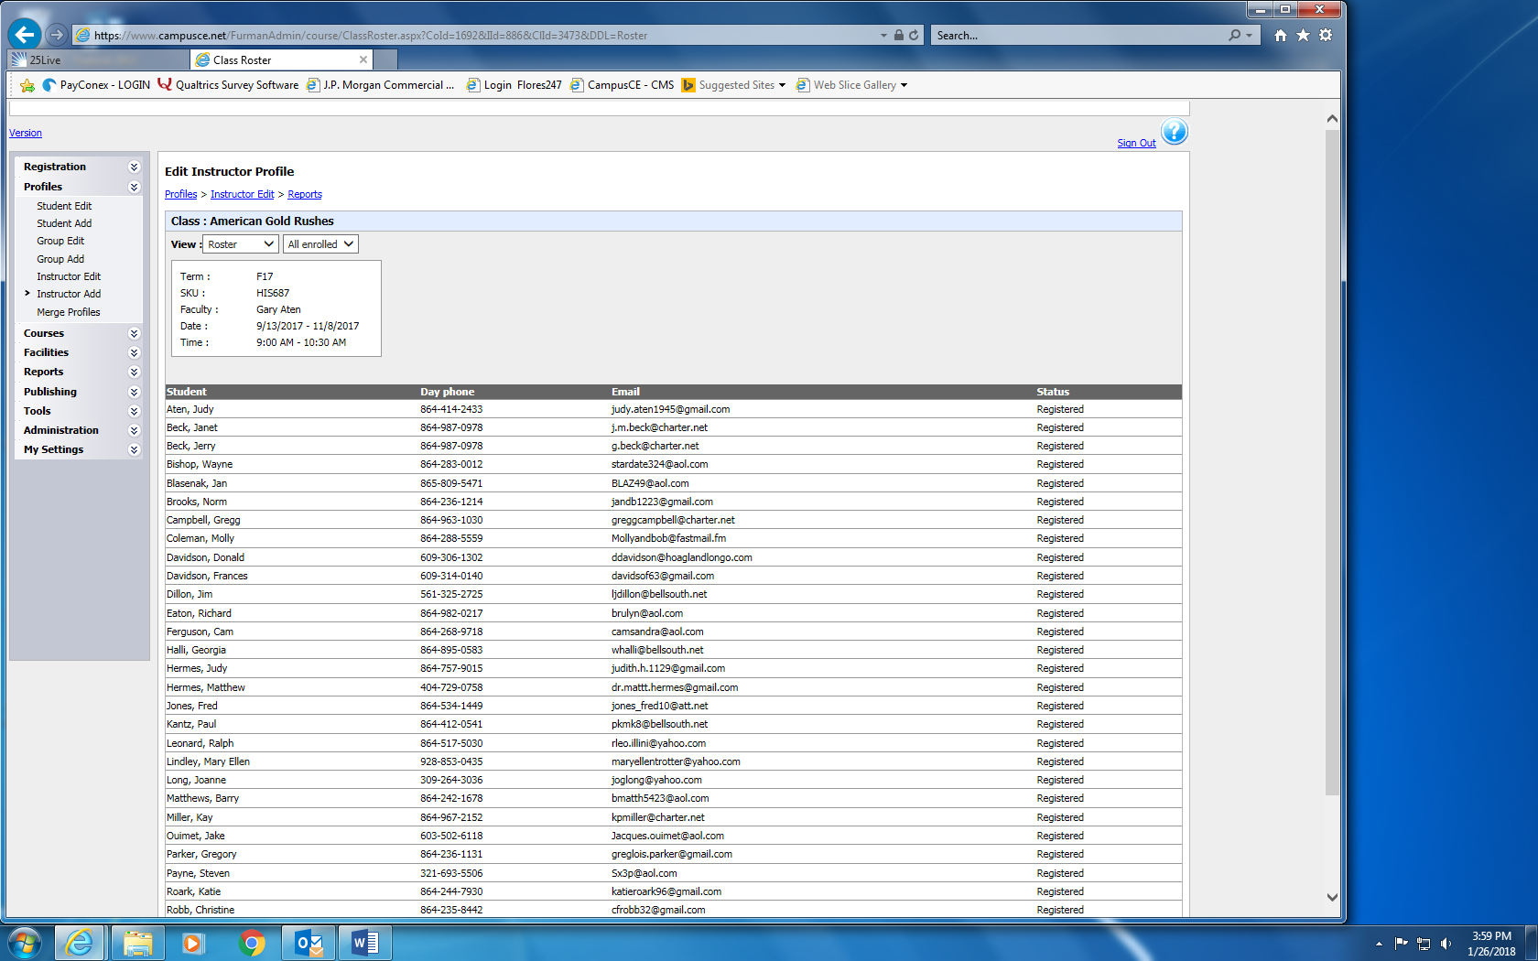
Sixth: Verify in the heading that you have the correct class for the current term. Note that the list of names is in alphabetical order by last name.
At this point you can print the list or export it to an Excel Spreadsheet. Copy and paste the entire page into an Excel spreadsheet and then copy and paste the email address column to the BCC line of your email. Compose the email and send.

