Recommended Self-Help Resources in Furman’s Library

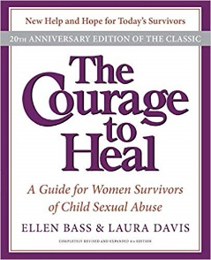
Excerpt from online blurb:
Cherished by survivors, and recommended by therapists and institutions everywhere, The Courage to Heal has often been called the bible of healing from child sexual abuse.

The Courage to Heal, by Ellen Bass and Laura Davis

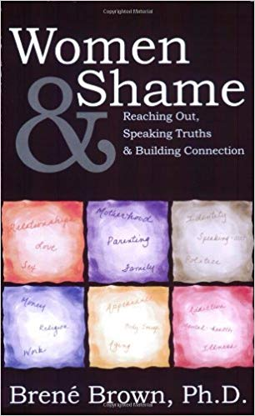
Excerpt from online blurb:
A compelling and provocative exploration of the complexities of shame and its impact on women's lives.

Women and Shame, by Brené Brown, PhD, LMSW

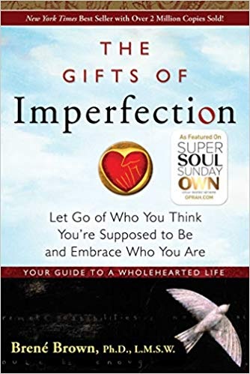
Excerpt from online blurb:
When our embarrassments and fears lie, we often listen to them anyway. They thwart our gratitude, acceptance, and compassion—our goodness.

The Gifts of Imperfection, by Brené Brown, PhD, LMSW

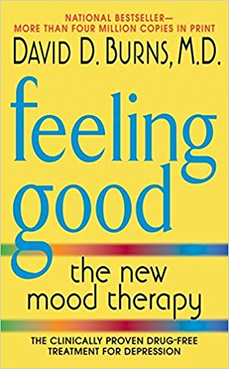
Excerpt from online blurb:
In Feeling Good, eminent psychiatrist, David D. Burns, M.D., outlines the remarkable, scientifically proven techniques that will immediately lift your spirits and help you develop a positive outlook on life.

Feeling Good, by David Burns, MD
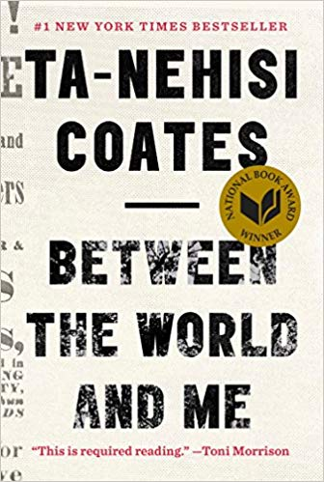
Excerpt from online blurb:
In a profound work that pivots from the biggest questions about American history and ideals to the most intimate concerns of a father for his son, Ta-Nehisi Coates offers a powerful new framework for understanding our nation’s history and current crisis.

Between The World and Me, by Ta-Nehisi Coates

Excerpt from online blurb:
Inspired by Our Bodies, Ourselves, the classic and powerful compendium written for and by women, Trans Bodies, Trans Selves is widely accessible to the transgender population, providing authoritative information in an inclusive and respectful way and representing the collective knowledge base of dozens of influential experts.
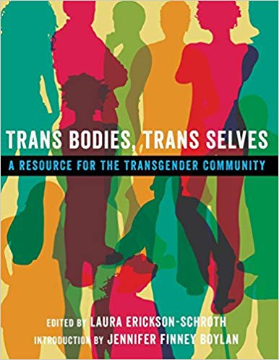

Trans Bodies Trans Selves, by Laura Erickson-Schroth

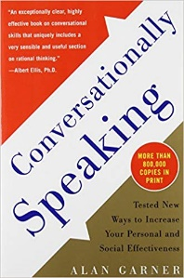
Excerpt from online blurb:
Conversationally Speaking has become the most popular book in the world teaching conversation skills.

Conversationally Speaking, by Alan Garner

Excerpt from online blurb:
In this unprecedented book, Grandin delivers a report from the country of autism. Writing from the dual perspectives of a scientist and an autistic person, she tells us how that country is experienced by its inhabitants and how she managed to breach its boundaries to function in the outside world.
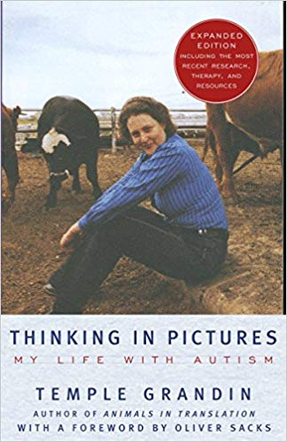

Thinking in Pictures: My Life with Autism, by Temple Grandin, PhD

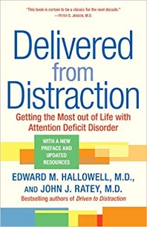
Excerpt from online blurb:
In this new book, Drs. Edward M. Hallowell and John J. Ratey build on the breakthroughs of Driven to Distraction to offer a comprehensive and entirely up-to-date guide to living a successful life with ADD.

Delivered from Distraction, by Edward Hallowell, PhD and John Ratey, MD

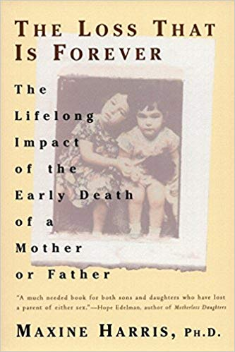
"Beautifully written and informative. Harris' eloquence is exceeded only by the compassion and insight she brings to this perplexing and formative experience."—Vamik D. Volkan, Univ. of Virginia.

The Loss that is Forever, by Maxine Harris, PhD

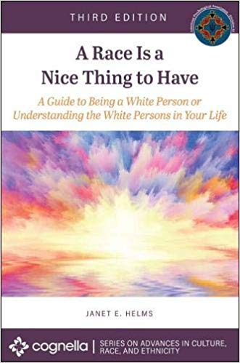
Excerpt from online blurb:
[This book] is designed to help white people fully recognize and accept their racial identity, assume the proper responsibility for ending racism, and develop an understanding of how racism impacts their own racial group.

A Race Is a Nice Thing to Have, by Janet Helms, PhD

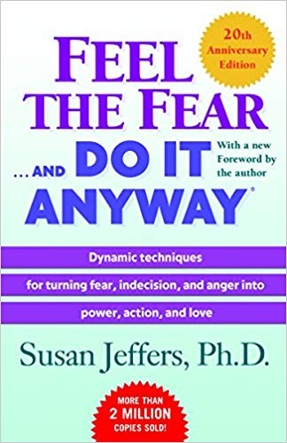
Excerpt from online blurb:
Are you afraid of making decisions . . . asking your boss for a raise . . . leaving an unfulfilling relationship . . . facing the future? Whatever your fear, here is your chance to push through it once and for all.

Feel the Fear and Do It Anyway, by Susan Jeffers, PhD

Excerpt from online blurb:
This book is about the small and large losses that happen to people, experiences that plunge them into a state of adjustment. It guides those moving through the mourning process and those who are struggling with depression and other symptoms of distress as they start to realize that they are grieving their loss.
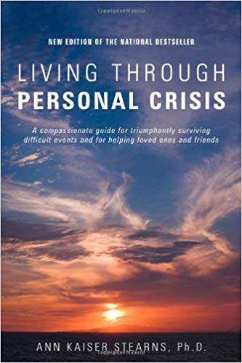

Living Through Personal Crisis, by Ann Kaiser Stearns, PhD

Excerpt from online blurb:
For those of us who have walked away from a conversation, meeting, or visit feeling violated and not understanding why, this book helps us recognize and set healthy boundaries.
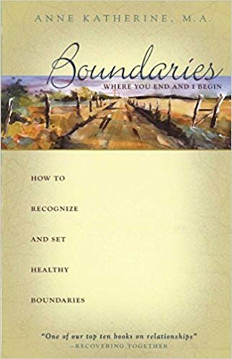

Boundaries: Where You End and I Begin, by Anne Katherine

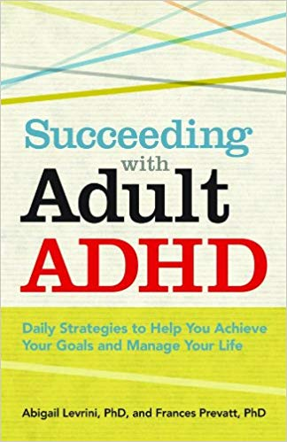
Excerpt from online blurb:
This book will help you overcome the challenges of adult ADHD and find fulfillment in taking the practical steps needed to achieve your goals.

Succeeding with Adult ADHD, by Abigail Levrini, PhD and Frances Prevatt, PhD

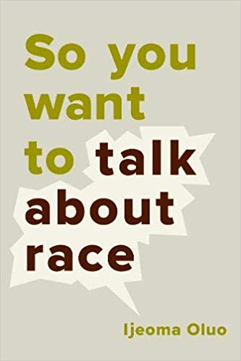
Excerpt from online blurb:
In this New York Times bestseller, Ijeoma Oluo offers a hard-hitting but user-friendly examination of race in America.

So You Want to Talk About Race, by Ijeoma Oluo

Excerpt from online blurb:
The Anger Management Sourcebook shows you how to empower yourself and redirect your anger into constructive behavior.
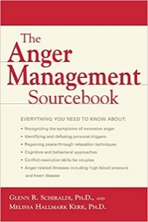

The Anger Management Sourcebook, by Glenn R. Schiraldi, PhD, and Melissa H. Kerr, PhD

Excerpt from online blurb:
A unique collection of 33 narratives by bereaved students and young adults, this books aims to help young adults who are grieving and provide guidance for those who seek to support them.
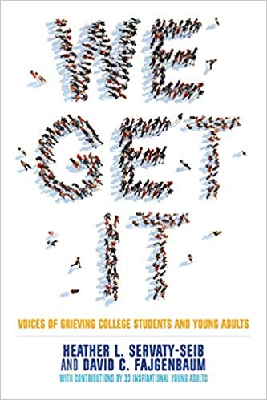

We Get It, by Heather Servaty-Seib, PhD, and David Fajgenbaum, PhD

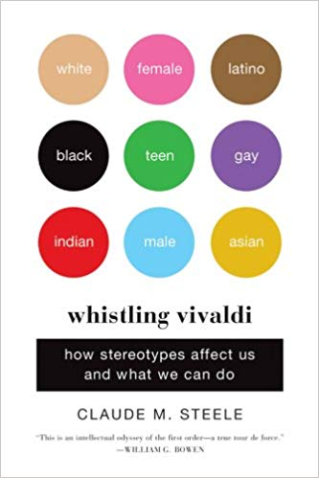
Excerpt from online blurb:
Claude M. Steele…offers a vivid first-person account of the research that supports his groundbreaking conclusions on stereotypes and identity.

Whistling Vivaldi, by Claude Steele, PhD

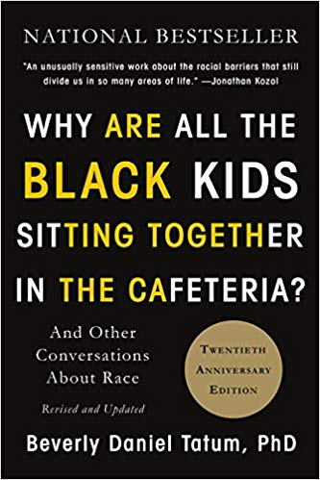
Excerpt from online blurb:
Beverly Daniel Tatum, a renowned authority on the psychology of racism, argues that straight talk about our racial identities is essential if we are serious about enabling communication across racial and ethnic divides.

Why Are All the Black Kids Sitting Together in the Cafeteria? by Beverly Tatum, PhD

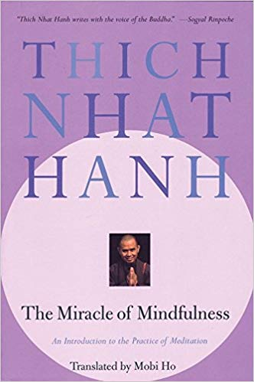
In this beautiful and lucid guide, Zen master Thich Nhat Hanh offers gentle anecdotes and practical exercise as a means of learning the skills of mindfulness--being awake and fully aware.

The Miracle of Mindfulness, by Thich Nhat Han

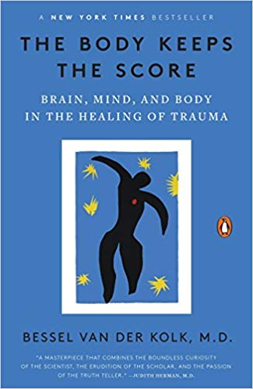
Excerpt from online blurb:
[van der Kolk] uses recent scientific advances to show how trauma literally reshapes both body and brain... He explores innovative treatments—from neurofeedback and meditation to sports, drama, and yoga—that offer new paths to recovery by activating the brain’s natural neuroplasticity.

The Body Keeps the Score, by Bessel van der Kolk, MD

