Moodle: Research Participants - PSY 111
Researcher Instructions
Congratulations! You have successfully registered your study for the PSY-111 Research Participant Pool. You are now enrolled in the Moodle course Research Participants – PSY 111. This is a tutorial on how to use the course to recruit, schedule and keep in touch with participants and how to confirm they attended their appointment and earned their credits.
Notice: When using Research Participants – PSY 111, you are NOT to access any parts of the course other than the scheduler for your study. Failure to follow this policy will result in loss of participant pool privileges.
Tutorial
Login to Moodle and under My Courses choose Research Participants – PSY111.
The course will look as below:
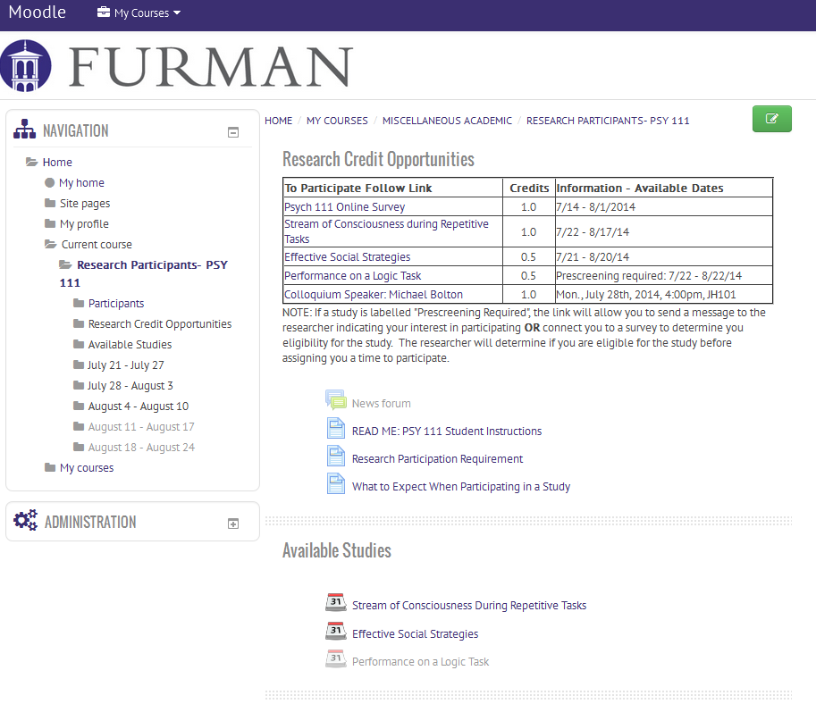

All studies will appear both in the Research Credit Opportunities chart at the top and in the next section under Available Studies. Click on the link in either of these locations to access the scheduler for a study.

Prescreening: If participants need to be prescreened before taking part in a study, clicking on the link in the Research Credit Opportunities chart will either allow a participant to send a message to the researcher indicating interest or connect them to a survey to determine their eligibility for the study. The researcher will determine eligibility for the study before assigning the participant a time. As a result, the scheduler for such a study is only accessible from the Available Studies section.
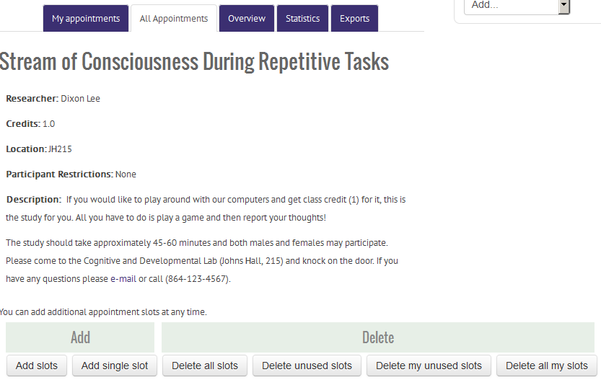
The scheduler for a study will look as below:
To add timeslots for your study, use the Add slots drop-down.
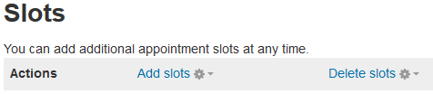
The Delete slots drop-down can be used to selectively delete timeslots.
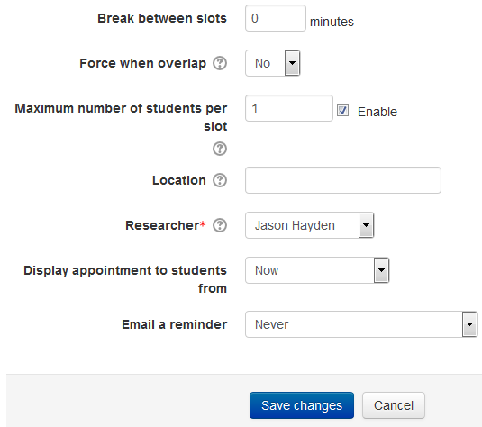
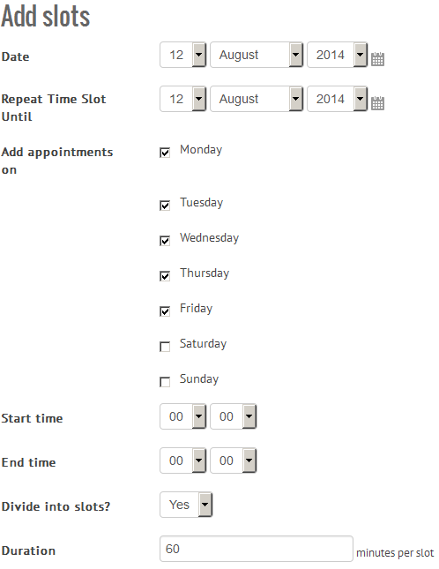
The Add slots screen will look as below. You can create timeslots at any time and of any duration. Slots for multiple students can be created and reminder emails sent. Please pay particular attention to the highlighted categories to be sure they are completed correctly.

Once you have created timeslots for your study, they will appear at the bottom of the scheduler:
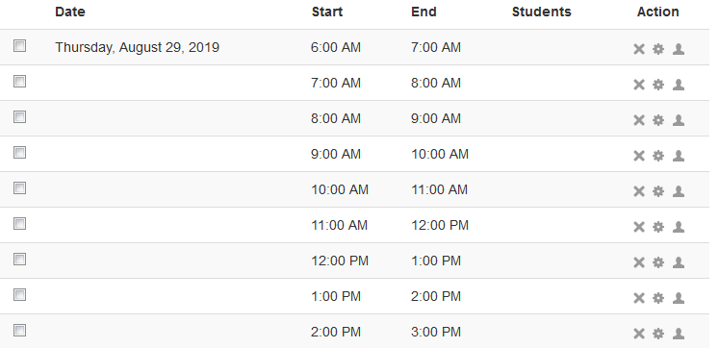
NOTE: There is not a cap on the number of participants you can schedule. If you nearing the desired number of participants for your study you may want to limit your available timeslots so you do not get more participants than you need.

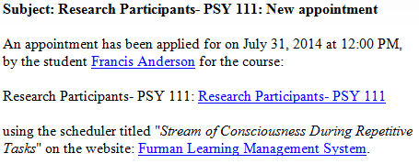
When participants sign up for timeslots, you will receive an email with the subject “Research Participants- PSY 111: New appointment” and details about the timeslot including date, time and student name.

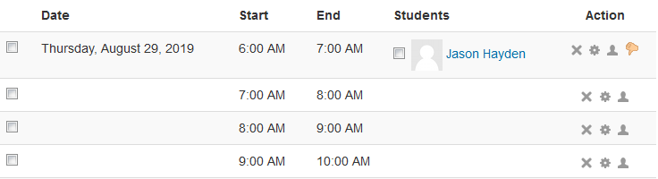
Names of scheduled participants will appear under the Students column as below:

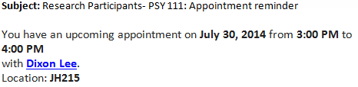
If you set up email reminders when creating slots, the participants will be sent a reminder with the time, date, researcher name and location of the appointment.
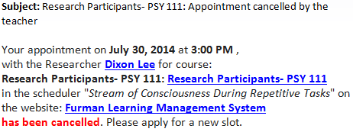
If an appointment must be cancelled (using the thumbs down icon), the participant also receives an email notification.
Contacting participants
Scheduled participants: Select the participant’s name as seen above under Slots to bring up their profile page which includes their email address.
Unscheduled participants: Beneath the listing of time slots in the scheduler is an alphabetical list of all PSY111 students that are NOT signed up for the current study.
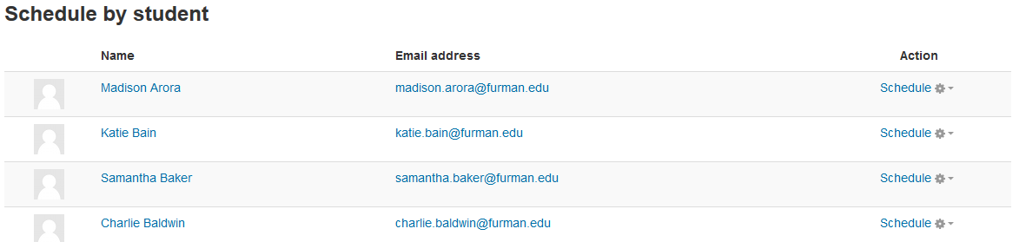
They can be contacted individually through their email links. It is also possible to add students directly to the schedule by selecting the Schedule drop-down and assigning the student an existing or new timeslot. Be certain that a time has been agreed on with the student before assigning them a timeslot.
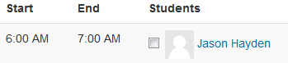
Credits: To indicate a participant attended the study, check off the box next to the. This MUST be done at the end of each day so that the participants are given the credits they have earned. NOTE: Checking off the Save seen box does not give the participant credit, it only indicates they have completed the study and earned the credit. The credit will actually be assigned by the administrator. A student who has received credit will have (1/1) beside their name in the schedule. Credits are updated each Friday so it is important that all participants for the week be checked off by Thursday night.
No Shows: Participants that do not keep their scheduled appointment are penalized the number of credits they were to earn, so do not remove them from their timeslot. Each Friday all scheduled participants that were not checked off as “seen” are penalized by the administrator. If the researcher wishes to attempt to contact the participant to reschedule them they must contact the administrator before Friday.
IMPORTANT: For any questions about this procedure or the Research Participant Pool in general, please contact Donna Greene.

