Furman University

STUDY SPACES INVENTORY

A guide to:

Individual Spaces

Group Spaces

Library Spaces

Multi-Use Spaces

Departmental Spaces

CREATED BY THE CENTER FOR ACADEMIC SUCCESS

Individual Study Spaces
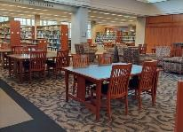

James B. Duke Library

Lower Level and First Floor Spaces

Quiet areas for individual studying

Scholar Study Rooms on the lower level can be reserved via the university library's website

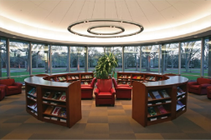

Sanders Science Library

Plyler Hall near the Kohrt Commons

Quiet space with tables for individual studying Computers with software available to use

1 reservable room for groups
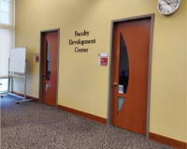

Center for Teaching and Learning 1st Floor of Duke Library

Conversational-level noise space

This space is mainly reserved for faculty resources
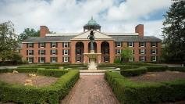

Personal Dorm Rooms

Study in your dorm room for a comfortable, quiet environment

Share your schedule with your roommates so you know times that you will be alone and able to concentrate. 29 rooms that can accommodate 6 students each

Group Study Spaces
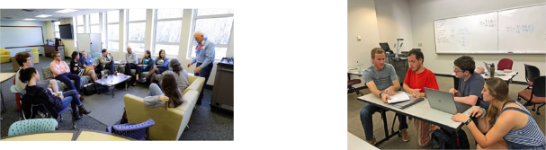

Modern Language Center (MLC)

Furman Hall 226

A conversational place for students

to practice language skills

Language Ambassadors hold times

for practicing and refining language skills

Mathematics Resource Center (MRC)

Riley Hall

A group-work space for students

to complete assignments and

collaborate with peers

Peer tutoring is available for

several math courses
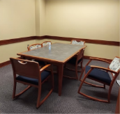

Group Study Rooms

Duke Library, Lower Level and First Floor
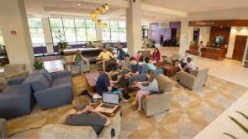

Trone Student Center

Behind the Library, next to the Dining Hall

A conversational loud space for students to study and work on projects

Rooms can be reserved via the university Ample gathering spaces are available for library's website both group and individual studying

Library Study Spaces

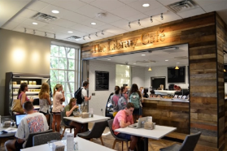

Library Cafe and Study Lounge

Accessed through Duke Library Front Porch

Café with snacks end coffee

A 24-hour conversational-quiet study lounge has 2 computers printer/scanners and a dry erase board

Study Room holds 14 people, 4 computers and 1 printer/copier

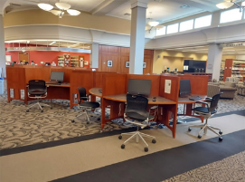
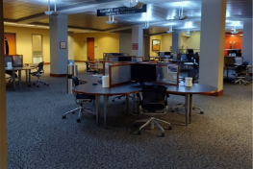

Multimedia Commons

Duke Library, Ground Floor

space for all students

Computer lab has 36 computers and I printer/copier for students to use

Reserve Duke Library Rooms online at:

https://libguides.furmamedu/library/study-rooms/home

or Scan QR code
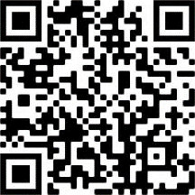

Multi-Uses Study Spaces

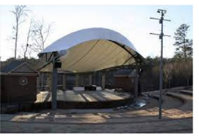

Lakeside Amphitheater

Along Lakeside Trail, next to the Shi Center for Sustainability

An outdoor space for individual or group studying

Outdoor seating through the amphitheater seats
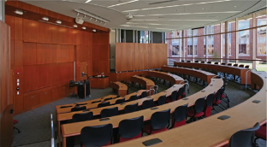

Empty Classrooms

Various Spaces Around Campus

Empty classrooms are a great quiet space for individual or group studying

Remember to be respectful of classes that may need the classroom space that you're studying in

Outdoor Benches and Tables

Various Spaces Around Campus

Outdoor spaces for individuals or small groups to study

Enjoy the many different beautiful Furman landscapes!
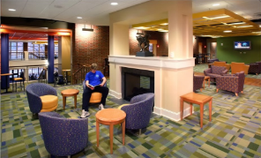

Dining Halls

Various Spaces Around Campus

Conversational loud spaces for individual or group studying

Open tables give you room to get work done and study snacks are always nearby!

Departmental Study Spaces

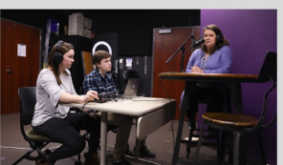

Communication Studies Media Lab

Furman Hall, Suite 135

A conversational space for Communication

majors to study and complete course work

Space has editing bays that can be reserved

along with classroom study space

A television studio and rental equipment are

also available here

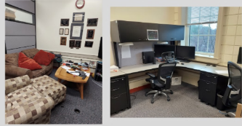

Computer Science Student Lounge

Riley Hall, Second Floor

Science students to work together and relax

Dell workstations with software are

available for use

Couches, a microwave, a fridge, and XBOX

360 are available

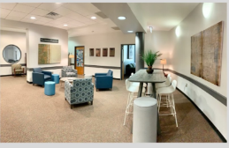

Economics Student Lounge and Study Space

Riley Hall 109

A conversational space for Economics

students to work individually or with a small group.

A computer lab is there with software majors to use available for Economics majors Lab space is available to practice laboratory teaching skills.

Education Department Methods Classroom

Hipp Hall 205

Conversational-loud space for Education

majors to study and practice techniques groups.

Laptops are available for Education
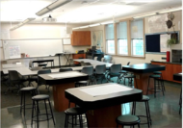

Education Department Methods Classroom

Hipp Hall 205

Conversational-loud space for Education

majors to study and practice techniques.

Laptops are available for Education.

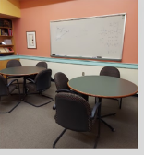

Fishbowl Study Space/Pigeonhole Lounge

Math Department, Riley Hall, 2nd Floor

Quiet spaces for Math majors to study and unwind majors

Worktables and whiteboards are available

Couches, computers, coffee and soft drinks make the Pigeonhole a great space for group studying.

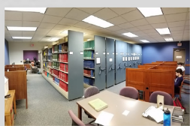

Maxwell Music Media Center and Library

Daniel Music Building

A quiet-conversational space for Music

Listening labs and research computers are for student use in both spaces.

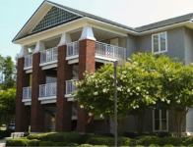

Modern Language Houses

North Village Residential Complex

Open to students who are residents of the Language Houses

A space to practice and refine your language skills. and learn about cultures and traditions
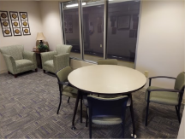

Physical Activities Center (PAC) PAC-101

A quiet-conversational space for

Health Science majors to study

A small space for individual or small group studying

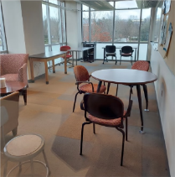

Physics Student Lounge

Plyier 202

A quiet conversational space for Physics majors

Lounge space can be accessed by students enrolled in Physics courses if they receive prior permission
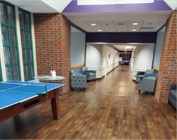

Sociology Farmer Commons

2nd Floor, Johns Hall

A conversational, open space for students

Workspaces and lounge space available for students to use individually or with a group
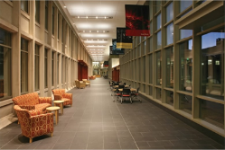

Townes Science Center

Plyler Hall

A quiet-conversational space for students to study

Can be conducive to individual and group studying sessions

This list of study spaces is not exhaustive! There are many spaces in buildings on campus that can be conducive to studying. Remember to be creative and comfortable when finding a space to get work done. Try new places. different noise levels, and different environments when trying to find a study space that works for you.

