Flipped Learning Toolkit for Students

What is a flipped classroom? The flipped classroom model is a method of learning that prioritizes active learning, student control over content exploration, and more direct interaction with peers and the course instructor. In previous courses, you were probably first exposed to a concept IN class through a presentation by your instructor, while your active exploration of that topic took place OUTSIDE of class (e.g. homework). The flipped classroom turns this process on its head, by providing you with the resources to first learn about a concept OUTSIDE of the classroom at your own pace, while spending more interactive time IN the classroom exploring and working through that information. Flipped learning has existed for years in many disciplines, and was implemented at Furman in several disciplines many years ago.

Traditional Classroom
+ | - Instructor prepares material to be delivered IN class.  - Students listen to lecture presentations and other guided instruction IN class and take notes for review later.  - Homework is assigned for students to explore material to refine understanding and work through problem areas OUTSIDE of class.

Flipped Classroom
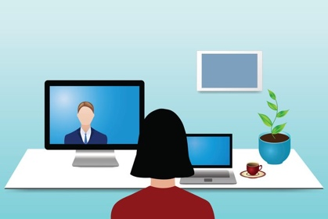  + | - Instructor records or prepares lectures/information for review OUTSIDE of class.  - Students watch/listen to content BEFORE coming to class and prepare questions for clarification.  - Class time is devoted to applied learning activities and more higher-order thinking tasks IN real-time.  - Students receive support from instructor and peers to enhance learning IN class.

Why is my instructor using a flipped classroom model? One of the primary benefits of the flipped learning model is that the less you ‘sit and listen’ IN class, the more you can ‘do and learn’ in that time. This hinges on the idea that students learn more effectively by using class time for active small group activities and individualized instructor attention. Because course content is available ‘beyond’ the walls of the classroom, you can access and engage with that information when it works best for you – giving you more freedom over how, when, and where you learn. And because class time is dedicated to hands-on exploration and thinking critically, you can work through the ideas you explored on your own by identifying problems in real-time, giving and gaining support from your peers in the learning process, and seeking clarification from your instructor long before you are asked to demonstrate understanding on a test.

Does it work? There is growing evidence that flipping the classroom can produce significant learning gains when compared to traditional instruction. The Flipped Learning Network reports that 67 percent of surveyed instructors saw an improvement in student test scores after utilizing the flipped learning model, and 80 percent reported an improvement in student motivation to learn.

Pre-Class Preparation Strategies: How can I organize my time OUTSIDE of class?
- Crate and run a study group
- Time Management Tip : use a visual calendar to track your time commitments
- Notetaking for videos and readings; find a partner in the class or use a study group to compare notes with to make sure you don’t miss anything
- Email professors early before class to ask questions or post in forum
- If optional support is provided, you should take advantage of those
- “The classroom is flipped; therefore, your study habits need to flip, too.” For example, you are used to learning in a lecture and then completing follow up activities/homework/application of material. Now you will learn before the class session, and then do activities/homework/application during class time. For first year students, this is probably very different than your high school learning experience.

In-Class Engagement Strategies: What can I do to make the most of class sessions?
- Identify questions you should ask and become comfortable asking them in the classroom
- Let go of imposter syndrome (easier said than done!)
- Make sure that you have prepared beforehand -- you have to do the work!

Post-Class Review Strategies: What strategies can I employ once class is complete?
- Identity an example from class and assess how well you understood it. What didn’t make sense for you? What additional questions do you have at this point? What do you need to review?
- Try to identify where you got stuck/lost. What clarification do you need to move forward from that point?
- Review what you did to prepare for this course. What worked well? What didn’t?

